WHEEL TORQUE AND RETORQUE POLICY & PROCEDURE

Introduction

- TASK:
To outline the policy and procedure for Energy Transport Logistics Wheel Torque and Retorque Policy.
- PURPOSE:
We at Energy Transport Logistics pride ourselves on having well maintained and safe equipment. This ensures that our drivers and customers are proud to be associated with us. And our friends and family feel safe driving next to us. To have those two things happen we must keep our equipment maintained at the highest level.
- SAFETY:
ETL is dedicated to the safety of its employees, representatives, supplier, contractors and the general public. It is our mission to ensure that all equipment is repaired and operated in the safest manner possible. All equipment maintenance decisions will be made with safety as the primary factor. All equipment will be maintained to the manufacturer’s standards using their specifications.
To that end, ETL requires that all parties repairing or inspection our units, to ensure that all Occupational Safety and Health Administration (OSHA) and state safety requirements and procedures be observed at all times.
Questions regarding the contents of this manual should be directed to the Fleet Manager (844) 737-7447 Ext 130

Wheel Torque & Retorque Policy
- Objective
The Wheel Retorque Policy of Energy Transport Logistics is designed in accordance with the Technology & Maintenance Council's (TMC) Recommended Practice 237, "Retorquing Guidelines for Disc Wheels”
Compliance with the following policy and all items contained therein is mandatory for all employees, vendors, contractors, and sub-contractors of the company.
- Policy
Anytime a wheel has been removed from a unit it must be document in the Wheel Retorque Log Smartsheet. After the retorque has been complete it must be update in the Wheel Retorque Log with the name of the vendor or employee who completed the retorque.
A wheel that has been removed for any reason is required to be torqued using a calibrated torque wrench. A retorque must be completed within 100 miles or upon arriving at your next terminal whichever is the earliest. The retorquing must adhere to the procedure outlined in this policy and procedure manual.
All torque wrenches must be professionally recalibrated every two years and a copy of the certificate must be kept on file for company owned torque wrenches. Vendors must be able to provide the torque wrench calibration certificate upon request.

- Torque Procedure

- Flat level surface, and position wheel chocks under the tires to prevent the unit from rolling.
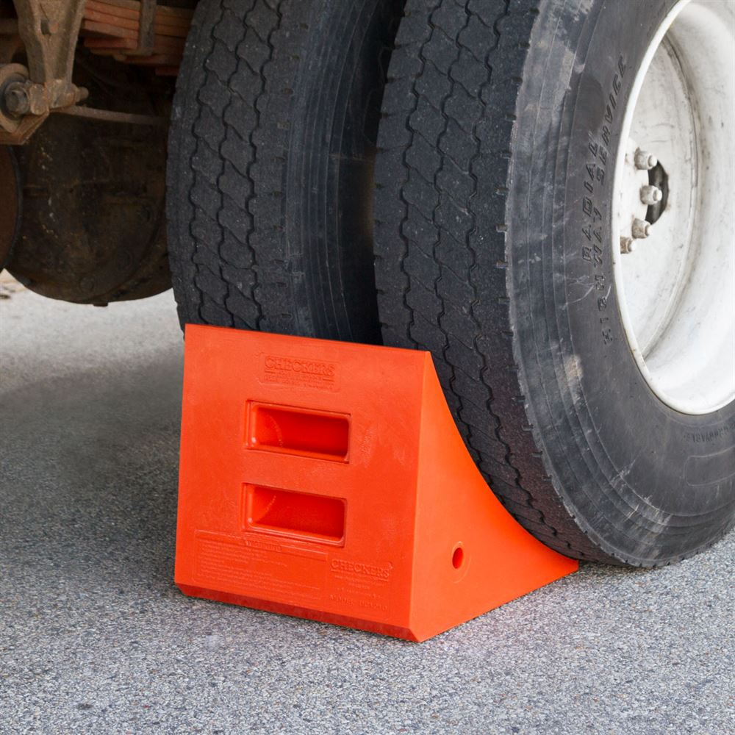
- Lock out and Tag out the unit in accordance with company policy.
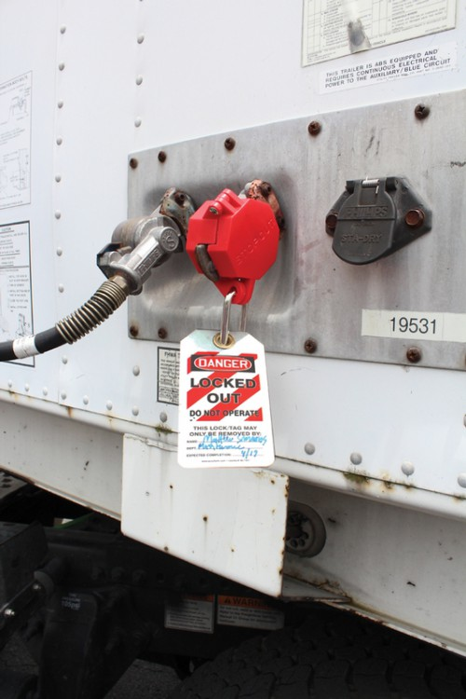

3. Clean and visually inspect the rim for any signs of damage, cracks, or out of round stud holes. Clean and inspect the hub mating surface and the studs for any signs of damage, excessive corrosion, loose studs or damaged studs.
4. Torque each lug nut to 450-500 FT lbs. using the appropriate torque sequence for the lug pattern.
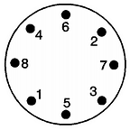
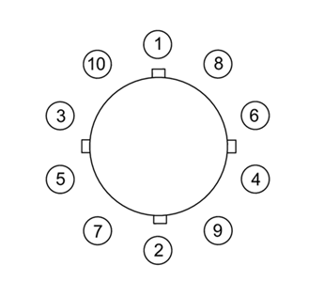

- Retorque Procedure

- Flat level surface, and position wheel chocks under the tires to prevent the unit from rolling.

- Lock out and Tag out the unit in accordance with company policy.

- Clean and visually inspect the rim for any signs of damage, cracks, or out of round stud holes. Clean and inspect the hub mating surface and the studs for any signs of damage, excessive corrosion, loose studs, or damaged studs.

- If any lug nuts were loose, that stud and the studs on each side of it must be replaced.

- Loosen all lug nuts at a minimum of 1/4 turn.

  - Failing to loosen the lug nus will not yield an accurate retorque.

- Retorque each lug nut to 450-500 FT lbs using the appropriate torque sequence for the lug pattern.
- Upon Completion of the retorque process the Terminal Managers will then update the Wheel Retorque Smart Sheet indicating the retorque has been completed.
ACKNOWLEDGEMENT OF RECEIPT OF MANUAL

This is to acknowledge that I have received a copy of the Wheel Torque and Retorque Policy. I understand that this manual is a guideline for proper preventative maintenance for Energy Transport Logistics. I also understand and agree that it is my responsibility to read and become familiar with the contents of this manual.

Date _______________________
Employee Signature _________________________________________________
Employee Name (Print) _______________________________________________
Company _______________________________________________

Return signed copy to Fleet Maintenance Manager

