ENERGY TRANSPORT LOGISTICS
TRAILER PM MANUAL
2020 Rev 1

Table of Contents

- Introduction……………………………………………...... 1
- Trailer Body Inspection……………………………….…... 2
  - Exterior
  - Interior
  - Doors
  - Door latches/locks
- Trailer Chassis Inspection………………………………… 3
  - Frame
  - Landing Gear
  - Suspension
- Shocks
ii. Air suspension
iii. Leaf Spring
  - Sliding Tandem (if applicable)
- Lighting & Electrical System Inspection…………………… 9
  - Exterior Lighting
  - Interior Lighting (if Applicable)
  - ABS System
- Brake system………………………………………………. 10
  - Shoes
  - Drums
  - Pads
  - Rotors
  - Caliper
  - Brake Chamber
  - Auto Slack Adjusters
  - S-Cams & S-Cam Tubes
  - Air Lines & Air Tanks

- Wheel End Components…………………………………… 21
  - Wheel Bearings *Annual Inspection
  - Hub Caps
  - Wheel Seals
  - Wheels
  - Tires
  - Lug Nuts
  - Wheel Studs

Introduction

- PURPOSE:
We at Energy Transport Logistics pride ourselves on having well maintained and safe equipment. This ensures that our drivers and customers are proud to be associated with us. And our friends and family feel safe driving next to us. To have those two things happen we must keep our equipment maintained at the highest level.
Success of our PM program will be assured through the cooperation of all of our employees. Assignment of personnel to the prescribed duties listed in this manual is essential for the preventative maintenance program to function properly and to be cost efficient.
- TASK:
All Trailer PMs will be conducted at 90 day intervals and will be conducted in accordance with 49 CFR 396.17 to ensure compliance with local and federal regulations. All preventative maintenance will be done according to the schedule or the equipment will not be available for dispatching until the preventative maintenance has been conducted and updated.
- SAFETY:
ETL is dedicated to the safety of its employees, representatives, supplier, contractors and the general public. It is our mission to ensure that all equipment is repaired and operated in the safest manner possible. All equipment maintenance decisions will be made with safety as the primary factor. All equipment will be maintained to the manufacturer’s standards using their specifications.
To that end, ETL requires that all parties repairing or inspection our units, to ensure that all Occupational Safety and Health Administration (OSHA) and state safety requirements and procedures be observed at all times.
Questions regarding the contents of this manual should be directed to the Fleet Manager (844) 737-7447 Ext 130

- Trailer Body Inspection
  - Exterior
    - Inspect the exterior walls for damage, loose panels, or missing fasteners.
    - Inspect all trim for damage, being loose or missing fasteners.
    - Inspect all DOT tape, markings, decals and placards (if applicable) replace as needed
    - Inspect mud flaps. Mud flaps should be free of holes, tears or damage that would prevent the mud flap from stopping debris.
    - Inspect anti-sails, verify they are in proper working order
  - Interior
    - Inspect the interior walls for damage, loose panels, or missing fasteners.
    - Inspect the floor for damage, loose panels or missing panels.
    - Inspect load securing devices (if applicable) for damage, loose or missing fasteners
  - Doors
    - Inspect doors for proper opening and closing
    - Inspect hinges for sagging when operating doors, inspect hinges for damaged, missing or loose components
    - Inspect door holds for damaged, missing or loose components
    - Lubricate door hinges
  - Door Latches/Locks
    - Inspect door latches for proper operation
    - Lubricate door latches

- Trailer Chassis Inspection
  - FRAME
    - Inspect frame for cracks, damage or rust
        - Any cracks, damage or excessive rust is OOS criteriaExcessive rust is considered large chunks of material coming off, or any holes in the frame.
        - Surface rust needs to be cleaned and painted.
    - Check for loose fasteners
      - Loose fasteners can be seen by rust streaks or rust around the bolts or nut.
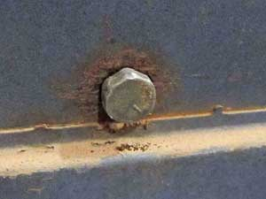
      - Replace all loose fasteners with new and torqued to factory specifications.
    - Check for unsecured air lines, wiring harnesses and components
      - Re-secure all air lines, harnesses or components as necessary.
    - Check air lines for excessive repairs
      - No more than 1 splice/connector in an 18” area
  - LANDING GEAR
    - Visual inspect landing gear for damage.
      - Inspect cross braces for bowing, bending or cracks.
      - Inspect for loose fasteners.
        - Replace all loose fasteners and torque to spec.
        - Loose fasteners can be identified by rust around the bolt head or streaks of rust from the bolt head running towards the ground.
      - Inspect the landing gear handle for damage, bends or loose fasteners
      - Inspect landing gear transmission for proper engagement from low to high.
      - Properly lubricate landing gear assembly.

  - SUSPENSION
    - Inspect shocks for signs of leaking, damage or loose fasteners
      - Signs of shock leaking are grounds for immediate replacement.
        - If it is just oil mist, clean shock and annotate to recheck on next PM. Misting is normal and not considered a leak.

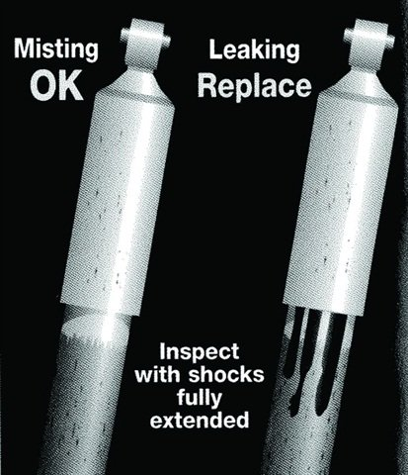

    - AIR SUSPENSION
    - Look for chafing, cracking or any signs of component damage. Look for misplaced air lines that may rub on air spring bellows.
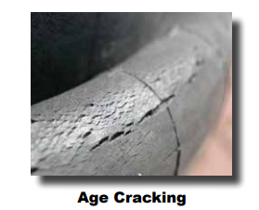

    - Ensure that the upper bead plate is tight against the underside of the frame and that the mountings show no sign of movement.
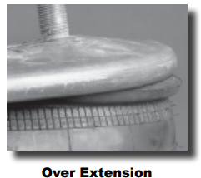
    - Air springs should be cleaned regularly, removing dirt and dust that may build up around the bead. Any grime in this area will eventually wear through the rubber bellows and cause premature failure to occur.

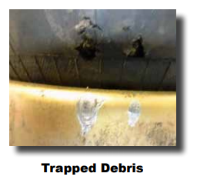

    - Inspect for leaks using a soap and water solution spray the air bags and fittings and look for signs of bubbling. 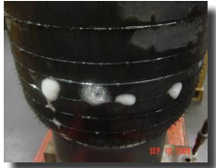
    - Inspect and torque U-bolts to manufacturer specifications
        - Refer to OEM manuals for proper torque spec
    - Inspect Pivot bushings for wear or deterioration
    - Inspect leveling valve for proper operation and proper install of height control rod.
    - CHECK FOR LOOSE FASTNERS AND RETORQUE ALL FASTENERS TO SPEC
    - Grease all chassis lubrication points

    - LEAF SPRING SUSPENSION
      - Check leaf spring eye bushings for signs of wear, damage or deterioration. 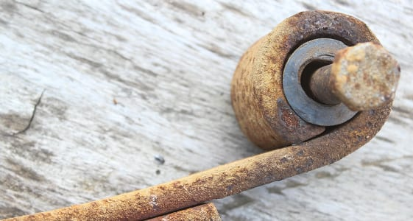

      - Inspect Leaf Springs for cracked or broken leaves
      - Inspect and torque U-bolts to manufacturer specifications.
        - Refer to OEM manuals for proper torque spec
      - Inspect Equalizer bushings for wear or deterioration
        - Typical signs of a worn equalizer bushing are when the trailer is on a flat level surface and the equalizer is not level
      - Inspect wear pads and replace, as necessary.
      - CHECK FOR LOOSE FASTNERS AND RETORQUE ALL FASTENERS TO SPEC
      - Grease all chassis lubrication points

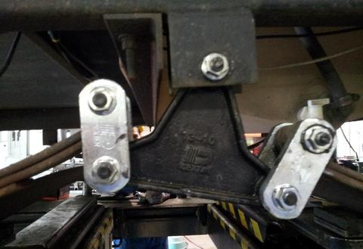

  - Sliding Tandem (if applicable)
    - Inspect the sliding tandem for any visual damage
      - Inspect all nuts and bolts for movement, and make sure they are tight. Torque all to spec, if any fasteners are loose replace with new.
      - Check for looseness of alignment pivot bolts. If loose realign axle replace fasteners and torque to spec.
      - Check the slider locking pins, slider pull-bar mechanism and slider wear pads for signs of excessive wear or binding. Repair or replace as needed.
      - Grease all chassis lubrication points

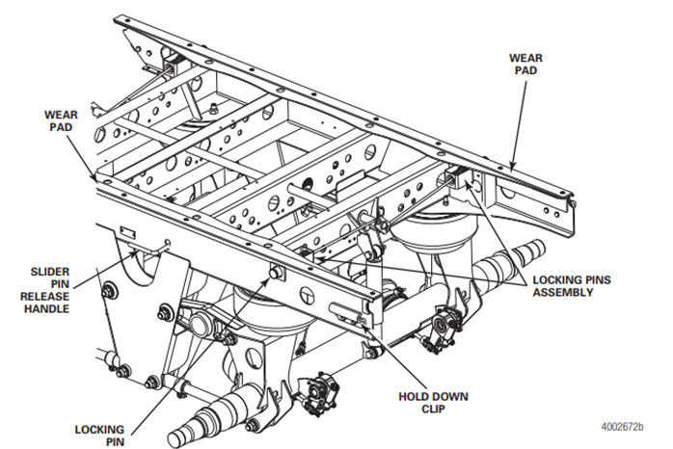
- LIGHTING SYSTEM
  - Exterior Lighting
    - Check operation of all exterior lights.
      - Operate 4 way flashers and check operation
      - Operate each turn signal and check operation
      - Operate brake lights and check operation
      - Operate tail lamps and check operation
      - Operate reverse lamp and check operation (if equipped)
        - If lights are LED 50% or more of the LED must be operating to be considered operational
      - Inspect 7 way socket for proper fitment of pigtail, no damaged pins and has di-electric grease in socket
  - Interior Lighting
    - Check operation of all interior lights inside the trailer (if equipped)
  - ABS System
    - Apply power to 7 way socket and listen for ABS System to cycle. Verify ABS light comes on and goes off
      - If the ABS light does not go off, the unit will need to be taken out of service and diagnostics and repairs must be performed before putting it back into service
      - If the ABS light does not come on when plugging in the 7-way plug, verify the light is plugged in. Perform further diagnostics if necessary.

- BRAKE SYSTEM
  - Shoes
    - Inspect brake shoes for oil saturation, cracking, uneven wear, proper fitment and thickness.
      - Minimum thickness and measurement
        - An air braked commercial motor vehicle shall not be operated with brake lining/pad thickness less than 6.4 mm ( 1/4 inch) or to the wear indicator if the lining is so marked (measured at the shoe center for drum brakes).
      - The shoes are required to be replaced if they are cracking,
        - A cracked brake shoe will continue to crack and no longer provide adequate stopping power
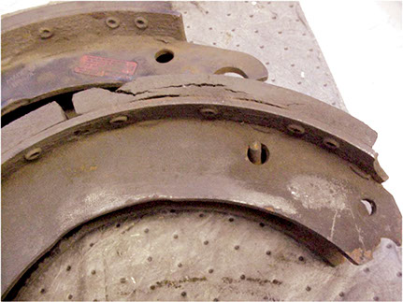

        - Oil-soaked brake shoes must be replaced and NEVER cleaned. Reduce stopping power and the potential for a wheel end fire are created by operating oil-soaked shoes.
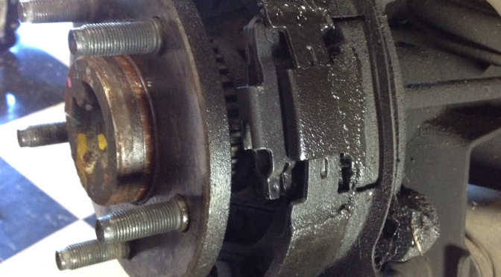

      - Uneven brake shoe wear
        - Uneven brake shoe wear is an indicator of something more serious and needs to be investigated further.
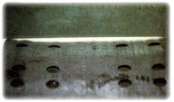
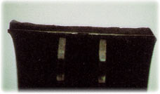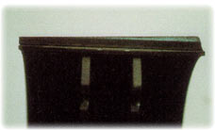
      - Proper brake shoe fitment
        - Brake shoes should fit evenly inside the drum and rest up against the outer lip of the drum
          - If they are not fitting properly, they need to be replaced.
  - DRUMS
    - Inspect drums
      - Inspect drums with out removing by checking the visible brake surface for signs of heat checking, cracking, discoloration or severe grooving. Any defects found will require disassembly of that wheel end and inspecting all components.
        - Inspecting for heat checks
          - Heat checking is fine cracks on the drum’s surface. This is a normal condition that results from continuous heating and cooling of the friction surface. Cracks that are one to two inches or more in length are usually deep and require that you replace the drum.
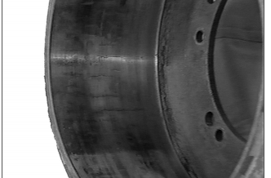

        - Inspect the drum for signs of cracking.
          - The drum has cracked, but may not show signs of wear, heat checking or hot spots. A drum can crack when the parking brake is set while the brakes are extremely hot. The cooling drum contracted on the brake shoes with enough force to crack the drum. Brake drum pilot interference with the hub or wheel pilot can also cause the entire cross-section of the drum to crack, if the drum was forced onto the pilot while interference is present.
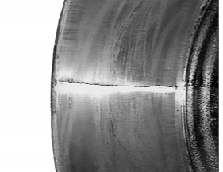
        - Inspect the drum for discoloration
          - Bluing of the drum. The inside of the brake drum has a blue tint, and components can be damaged or deformed. These conditions indicate that extremely high temperatures occurred during operation. Replace the drum
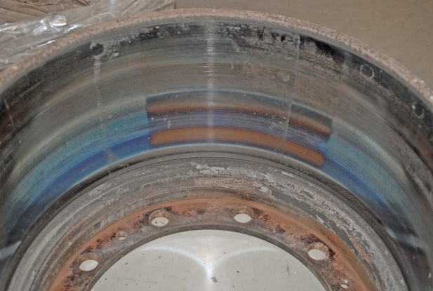

          - Hot spotting (Black Spots): Hot spotting is black spots on a drum’s surface that can appear in the following ways, all require replacement of the drum
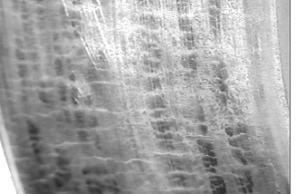
            - Over the entire surface (uniform).

            - On one side only.
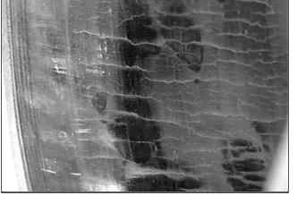

            - In three equally distant places.
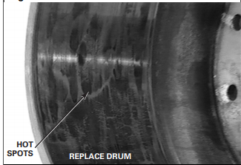

        - Inspect the drum for Scoring (Grooving)
          - Scoring (grooving) are depressions in the drum’s circumference that are deeper than 0.10-inch and wider than 0.030-inch. Replace the drum and linings. 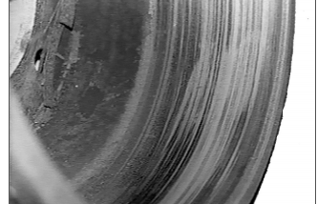

  - DISC BRAKE PADS
    - Thickness
      - Title 49 CFR § 393.47(d)(2) states that the thickness of the brake lining and pads of non-steering axle brakes on an air braked commercial motor vehicle shall not be less than 3.2 mm (1/8 inch) if disc brakes are used.
    - Inspecting direct mount air disc brake system
      - On a direct-mounted air disc brake system, at each wheel-end, check the brake for the following: Loose parts(such as chamber and caliper mounting bolts, pad retaining components, etc.), broken or cracked air hoses, air system leaks, and damaged components. Check that brake hoses and cables are properly secured but allow the caliper full movement during normal operation.
      - The presence of brake pads, if visible. Also, check the condition of the rotor for visual signs of extreme pad wear, a missing brake pad or a pad that is inserted backward with the backing plate against the rotor (metal-to-metal contact). Ensure that brake pad hold-down springs and pad retaining bars are present and in the correct position.
      - Oil or grease contamination of brake rotor and/or pad. Oil or grease contamination requires pad replacement and the rotor to be cleaned.
      - Check for uneven wear on the disc brake pads. Uneven wear can indicate a serious brake issue.
        - If the outer pad is worn more than the inner pad, this is indicative of the caliper float pins being stuck. The caliper must be replaced

        - If the inner pad is worn more than the outer pad, this is indicative of a stuck caliper. The caliper must be replaced

        - Tapered pad wear will appear as a slope from one portion of the pad to another. The caliper must be replaced.

        - Cracked, glazing or lifted edges will happen due to distress in the pad, repeated heavy braking, or brakes that were adjusted too tight. Replace the pad and make sure brakes are properly adjusted.

  - CALIPERS
    - Inspect calipers for proper movement, push and pull the caliper by hand and check for all covers, retainer and clips are in place.
    - Inspect caliper mounting bolts for proper installation. If loose replace and torque to spec
    - Visual inspect boots for cuts or tears and that they are properly installed.
    - Inspect proper caliper free movement. On level ground, with the wheels chocked and the parking brake temporarily released, check for movement of the brake caliper. This small movement, less than 0.80" (2 mm) - approximately the thickness of a nickel - in the inboard/outboard direction indicates that the brake is moving properly on its guide pins. If the caliper has no movement or appears to move greater than the distances above, a full wheel-removed inspection will be necessary.
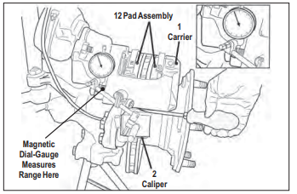
  - Rotor
    - Visually inspect the rotor for signs of overheating, cracking or grooving
      - Signs of overheating are blue, or blacks spots on the rotor and a red-orange tint to the non-machined surface of the outer rotor edge.
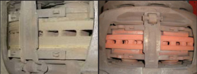
      - Perform a visual inspection for cracks. Cracks running in the radial direction (inside to outside) that are less than 1.5mm (0.06 in.) deep or wide are acceptable. Cracks are only acceptable if they are less than 75% of the width of the rotor contact area. Cracks that reach either edge of the rotor are not acceptable.
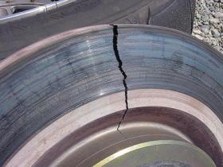

      - Visual inspect for grooves or scoring in the rotor. Grooves deeper than 1.0mm (0.04 in) will require the rotor to be replaced.
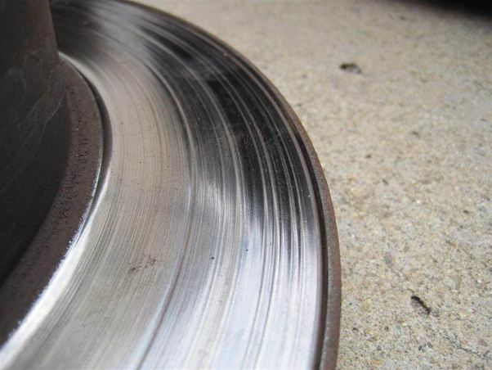

    - Inspect rotor for minimum thickness. Rotor minimum is 37MM measured at the thinnest point.

  - Brake chamber
    - Visual inspect brake chamber for physical damage and proper mounting
    - Verify brake chamber is not caged and caging bolt is present in slot.
    - Verify brake chambers match on all wheel ends.
    - Verify proper brake chamber stroke using the appropriate gauge.
      - Stroke will vary depending on brake chamber type
  - Auto Slack Adjusters
    - Visual inspect slack adjusters for any signs of damage
    - Check for proper lubrication and grease the ASA
    - Check for proper stroke using an approved brake stroke gauge. Proper stroke length will depend on the brake chamber size. If stroke is not in spec then replace the ASA
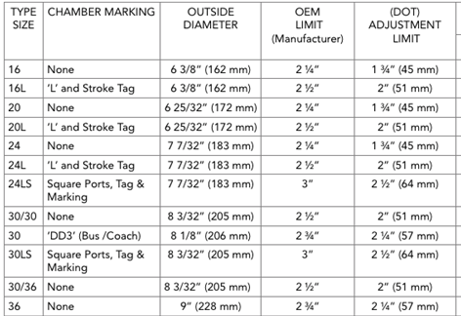
    - Verify brake shores are in adjustment if they are not then replace the ASA
  - S-Cams & S-Cam Tubes
    - Inspect cam tubes for cracks, loose hardware or physical damage. If any is found, then a full tear down of that wheel end brake system is necessary.
    - Check cam bushing for wear by pressing up and pulling down on the ASA. Any excessive movement will require a full tear down and inspection of the brake components.
    - Properly lubricate the S-Cams and S-Cam tubes
  - Air Lines/Tanks
    - Inspect air lines from front of the trailer to the rear.
      - Verify the air lines are properly mounted, they are mounted away from pinch points, sharp edges and are secured to prevent damage to the air lines
      - Inspect air lines for chaffing, kinks, cuts, or dry rot. If any is found repair or replace the air line.
      - Verify the air lines do not have excessive splices, no more than 2 splices in an 18-inch section of airline.
      - Listen for audible air leaks, if any air leaks are heard, perform a visual leak test using a soapy-water solution to pin point the leak and repair the leak.
    - Inspect trailer air tank (if equipped)
      - Visual inspect air tank for signs of damage, rust and verify proper mounting.
      - Verify air tank is free of water and air tank drain has a pull cable to allow the driver to operate the drain with out having to go under the trailer.
- Wheel End Components

  - Wheel Bearings -To be performed once a year

    - Lift wheel end and spin wheel, listen and feel for any roughness in the rotation. If any is heard or felt a full teardown is required.
    - Remove hubcap and perform a wheel bearing end play check. Using a magnetic dial indicator. The dial indicator should be attached to the hub or brake drum with its magnetic base. Adjust the dial indicator so that its plunger is against the end of the spindle with its line of action approximately parallel to the axis of the spindle. Grasp the wheel or hub assembly at the 3 o’clock and 9 o’clock positions. Push and pull the wheel-end assembly in and out while oscillating the wheel approximately 45 degrees. Stop oscillating the hub so that the dial indicator tip is in the same position as it was before oscillation began. Read the bearing end-play as the total indicator movement. *Acceptable end-play is .001"-.005"
      - If the end-play is out of spec, adjust bearings.
  - Hub Caps

    - Visually inspect the hub cap for broken bolts, broken window fasteners, missing expansion plug or plugged breather port. If any issues are found replace, as necessary.
    - Clean the hub cap to remove any built-up dirt and road grime.
    - Visual inspect hub cap window. If the fluid level can not be easily seen with the naked eye replace the hub cab.

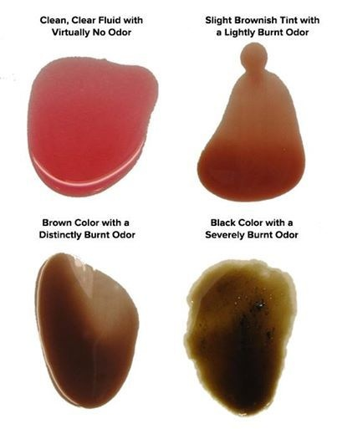
    - Inspect hub cap for sign of a hub cap seal leak. If a leak is present remove and replace hub cap gasket. Fill hub with fresh fluid (or grease if equipped). Remove rubber plug and visually inspect fluid for discoloration, or signs of the fluid being burnt. Use a magnet to check the fluid for metal particles. If the fluid is burnt, discolored or has metal particles, a full tear down and inspection of that wheel end is mandatory.
    - Verify proper fluid level inside the hub, top off, as necessary. Use caution to not overfill. Overfilling will result in pre-mature wheel seal failure.
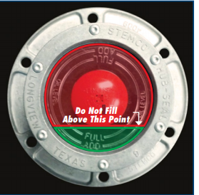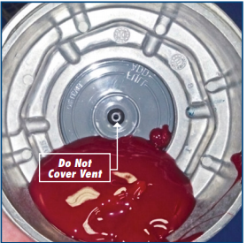
  - Wheel Seals
    - Visually inspect the wheel seals for leaks.
      - Class I Leaks. Class I leaks are identified by a wetness or discoloration not great enough to form drops. It is more of a seepage than a leak. Seepage can be a normal occurrence during large temperature swings because metal and rubber expand at different rates.
        - Clean seal area well and release the unit after completing the PM
      - Class II Leaks. Class II leaks are identified by a flow of fluid great enough to form drops but not great enough to cause the drops to fall from the leak point.
        - Class 2 oil leaks require a full tear down and wheel seal replacement. During wheel seal replacement inspect wheel bearings, races and spindle for any signs of scoring, heat damage or pitting of the metal.
      - Class III Leaks. Class III leaks are identified by a flow of fluid great enough to form drops that fall from the leak point.
        - Class 3 oil leaks require a full tear down and wheel seal replacement. During wheel seal replacement inspect wheel bearings, races and spindle for any signs of scoring, heat damage or pitting of the metal.
  - Wheels
    - Visually inspect wheels for cracks, bent rim, or rust.
    - Check around lug nuts for signs of rust, which indicates a loose lug nut.
      - If no loose lug nuts are found, recheck torque on all lug nuts using a calibrated torque wrench.
      - If loose lug nuts are found, the wheel stud associated with the loose lug nut and the two surrounding MUST be replaced.
        - Wheels will be torqued to 450-500ft lbs using a calibrated torque wrench.
        - ANY WHEEL THAT HAS BEEN REMOVED MUT BE RETORQUED WITHIN 100 MILES.
        - When a wheel has been removed you must inspect the lug nut holes to verify, they are not worn, or damaged.

  - Tires
    - Tires should be checked for improper wear patterns, legal tread depth, physical damage and proper inflation.
      - Visual inspect the tire for cuts, building, chunks of tire rubber missing, tread separation, and improper recap seams. If any of the following conditions exist refer to the Radial Tire Conditions Analysis Guide or remove the tire and have it verified by the tire vendor.
      - Inspect for any foreign object penetration. Do not remove the object. Take the tire off the unit and have it inspected for re-use by the tire vendor.
      - Tread depth needs to be checked in 3 points across the tire; outer, center and inner tread groove. It must also be measured at the lowest point on the tire.
        - Minimum tread depth is 4/32” at the lowest point on the tire if a tire is at 4/32” it is out of service. Tires should be matched according to size, with no variation greater than 1/8” on the same wheel end or across the axle.
      - When checking the tire pressure if the tire was lower than 15 psi above spec, the tire needs to be removed and sent for inspection.
          - Running under-inflated tires for an extended period of time will increase the chances of a catastrophic blow out.

ACKNOWLEDGEMENT OF RECEIPT OF MANUAL

This is to acknowledge that I have received a copy of the Trailer Preventative Maintenance Manual 2020 Rev 1. I understand that this manual is a guideline for proper preventative maintenance for Energy Transport Logistics. I also understand and agree that it is my responsibility to read and become familiar with the contents of this manual.

Date _______________________
Employee Signature _________________________________________________
Employee Name (Print) _______________________________________________
Company _______________________________________________

Return signed copy to Fleet Maintenance Manager

