ENERGY TRANSPORT LOGISTICS
TRACTOR PM MANUAL
2020 Rev 1

Contents
II. Introduction 1
A. PURPOSE: 1
B. TASK: 1
C. SAFETY: 1
I. M1 INSPECTION (60 DAY) 2
A. Brake System 2
b. Hub 12
D. Suspension 17
E. Alternator, Battery, and Starter Check 21
F. Check fluid levels 22
G. Check Steer Axle components 22
H. Emergency Equipment 22
I. Drive line 22
J. Engine 22
K. 5th Wheel 23
L. Cab/Body 23
III. M2 Inspection-40,000 Mile Service 24
A. Lube Oil and Filter Service 24
B. Cooling System 24
IV. M3 Inspection-250,000 miles 24
A. Transmission Inspection 24
B. Differential Inspection 25
C. Coolant 25
D. Desiccant Dryer Cartridge 25
V. Aftertreatment PM Service-3 years or 350,000 miles 25
A. DPF Filter 25
B. DEF Filter replacement 25
VI. Valve Lash Adjustment- 500,000 miles 26
A. Initial adjustment 26
B. Secondary adjustment 26

Introduction

PURPOSE:
We at Energy Transport Logistics pride ourselves on having well maintained and safe equipment. This ensures that our drivers and customers are proud to be associated with us. And our friends and family feel safe driving next to us. To have those two things happen we must keep our equipment maintained at the highest level.
Success of our PM program will be assured through the cooperation of all our employees. Assignment of personnel to the prescribed duties listed in this manual is essential for the preventative maintenance program to function properly and to be cost efficient.

TASK:
All Tractor PMs will be conducted at 60-day intervals and will be conducted in accordance with 49 CFR 396.17 to ensure compliance with local and federal regulations. All preventative maintenance will be done according to the schedule or the equipment will not be available for dispatching until the preventative maintenance has been conducted and updated.

SAFETY:
ETL is dedicated to the safety of its employees, representatives, supplier, contractors and the general public. It is our mission to ensure that all equipment is repaired and operated in the safest manner possible. All equipment maintenance decisions will be made with safety as the primary factor. All equipment will be maintained to the manufacturer’s standards using their specifications.
To that end, ETL requires that all parties repairing or inspection our units, to ensure that all Occupational Safety and Health Administration (OSHA) and state safety requirements and procedures be always observed.
Questions regarding the contents of this manual should be directed to the Fleet Manager (844) 737-7447 Ext 130

M1 INSPECTION (60 DAY)
The M1 inspection will be conducted every 60 days. During the M1 inspection the following items will be checked:

Brake System
Brake shoe linings will be checked for proper thickness
        - Minimum shoe thickness: an air braked commercial motor vehicle shall not be operated with brake lining/pad thickness less than 6.4 mm ( 1/4 inch) or to the wear indicator if the lining is so marked (measured at the shoe center for drum brakes).
        - The shoes are required to be replaced if they are cracking, A cracked brake shoe will continue to crack and no longer provide adequate stopping power.
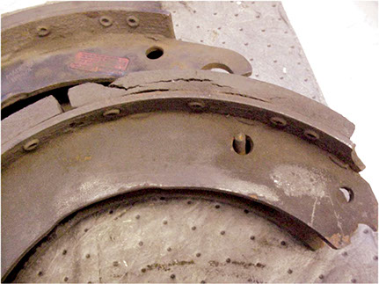
        - Oil-soaked brake shoes must be replaced and NEVER cleaned. Reduce stopping power and the potential for a wheel end fire are created by operating oil-soaked shoes.
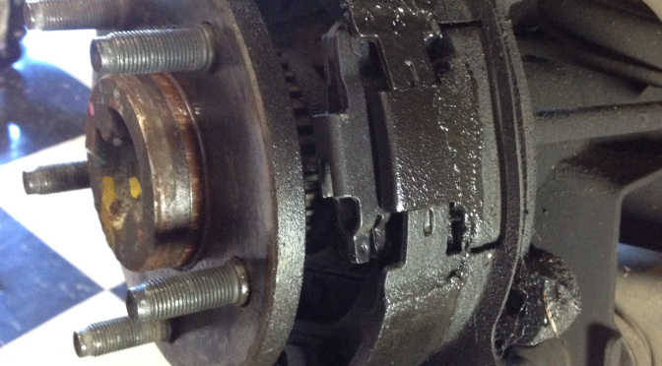
    - Uneven brake shoe wear
- Uneven brake shoe wear is an indicator of something more serious and needs to be investigated further
  - Proper brake shoe fitment
        - Brake shoes should fit evenly inside the drum and rest up against the outer lip of the drum. If they are not fitting properly, they need to be replaced.
- Drums
        - Inspect Drums:Inspect drums without removing by checking the visible brake surface for signs of heat checking, cracking, discoloration or severe grooving. Any defects found will require disassembly of that wheel end and inspecting all components

        - Inspecting for heat checks: Heat checking is fine cracks on the drum’s surface. This is a normal condition that results from continuous heating and cooling of the friction surface. Cracks that are one to two inches or more in length are usually deep and require that you replace the drum.
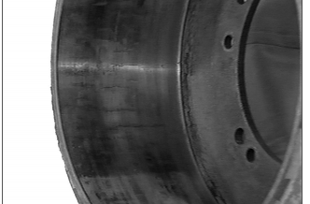
        - Inspect the drum for signs of cracking. The drum has cracked, but may not show signs of wear, heat checking or hot spots. A drum can crack when the parking brake is set while the brakes are extremely hot. The cooling drum contracted on the brake shoes with enough force to crack the drum. Brake drum pilot interference with the hub or wheel pilot can also cause the entire cross-section of the drum to crack if the drum was forced onto the pilot while interference is present.

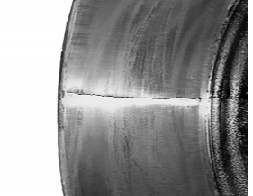

- Inspect the drum for discoloration:
        - Bluing of the drum. The inside of the brake drum has a blue tint, and components can be damaged or deformed. These conditions indicate that extremely high temperatures occurred during operation. Replace the drum.
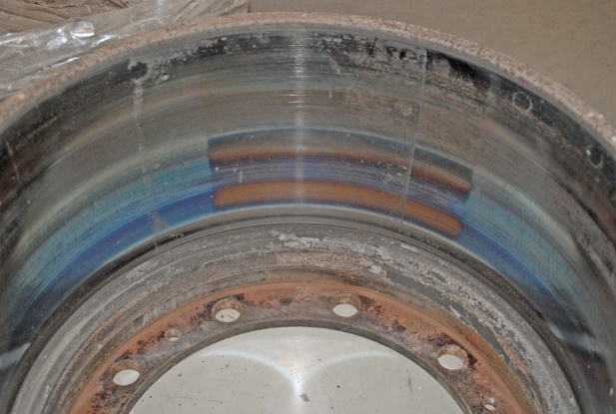

- Hot spotting (Black Spots): Hot spotting is black spots on a drum’s surface that can appear in the following ways, all require replacement of the drum
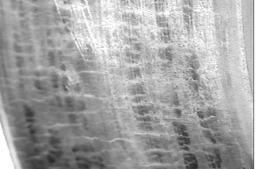
Over the entire surface

On one side only.
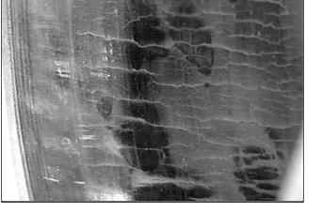
In three equally distant places.
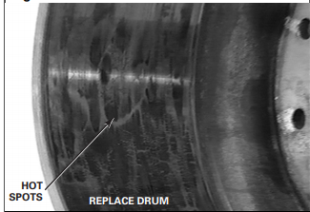

v. Inspect the drum for Scoring (Grooving)
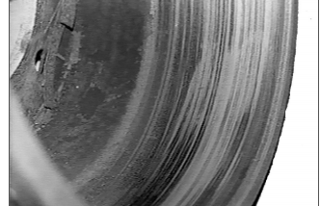
  - Scoring (grooving) are depressions in the drum’s circumference that are deeper than 0.10-inch and wider than 0.030-inch. Replace the drum and linings.

- DISC BRAKE PADS
    - Thickness
    - Title 49 CFR § 393.47(d)(2) states that the thickness of the brake lining and pads of non-steering axle brakes on an air braked commercial motor vehicle shall not be less than 3.2 mm (1/8 inch) if disc brakes are used.
- Inspecting direct mount air disc brake system
    - On a direct-mounted air disc brake system, at each wheel-end, check the brake for the following: Loose parts(such as chamber and caliper mounting bolts, pad retaining components, etc.), broken or cracked air hoses, air system leaks, and damaged components. Check that brake hoses and cables are properly secured but allow the caliper full movement during normal operation.
    - The presence of brake pads, if visible. Also, check the condition of the rotor for visual signs of extreme pad wear, a missing brake pad or a pad that is inserted backward with the backing plate against the rotor (metal-to-metal contact). Ensure that brake pad hold-down springs and pad retaining bars are present and in the correct position.
    - Oil or grease contamination of brake rotor and/or pad. Oil or grease contamination requires pad replacement and the rotor to be cleaned.
    - Check for uneven wear on the disc brake pads. Uneven wear can indicate a serious brake issue.
      - If the outer pad is worn more than the inner pad, this is indicative of the caliper float pins being stuck. The caliper must be replaced
      - If the inner pad is worn more than the outer pad, this is indicative of a stuck caliper. The caliper must be replaced
      - Tapered pad wear will appear as a slope from one portion of the pad to another. The caliper must be replaced.
      - Cracked, glazing or lifted edges will happen due to distress in the pad, repeated heavy braking, or brakes that were adjusted too tight. Replace the pad and make sure brakes are properly adjusted.

- Calipers
    - Inspect calipers for proper movement, push and pull the caliper by hand and check for all covers, retainer and clips are in place.
    - Inspect caliper mounting bolts for proper installation. If loose replace and torque to spec
    - Visual inspect boots for cuts or tears and that they are properly installed.
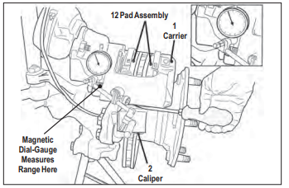
    - Inspect proper caliper free movement. On level ground, with the wheels chocked and the parking brake temporarily released, check for movement of the brake caliper. This small movement, less than 0.80" (2 mm) - approximately the thickness of a nickel - in the inboard/outboard direction indicates that the brake is moving properly on its guide pins. If the caliper has no movement or appears to move greater than the distances above, a full wheel-removed inspection will be necessary.
- Rotor
  - Visually inspect the rotor for signs of overheating, cracking or grooving
      - Signs of overheating are blue, or blacks spots on the rotor and a red-orange tint to the non-machined surface of the outer rotor edge.
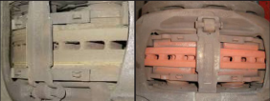
      - Perform a visual inspection for cracks. Cracks running in the radial direction (inside to outside) that are less than 1.5mm (0.06 in.) deep or wide are acceptable. Cracks are only acceptable if they are less than 75% of the width of the rotor contact area. Cracks that reach either edge of the rotor are not acceptable.
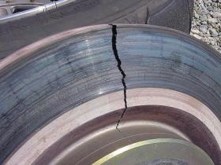

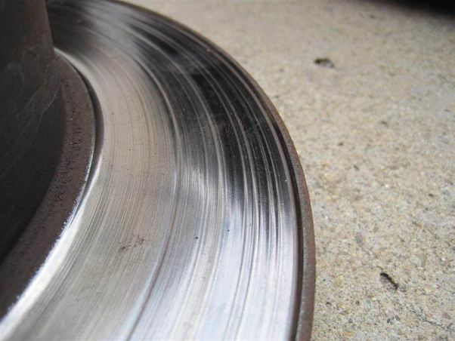
      - Visual inspect for grooves or scoring in the rotor. Grooves deeper than 1.0mm (0.04 in) will require the rotor to be replaced.

      - Inspect rotor for minimum thickness. Rotor minimum is 37MM measured at the thinnest point.

- Brake chamber
    - Visual inspect brake chamber for physical damage and proper mounting
    - Verify brake chamber is not caged and caging bolt is present in slot.
    - Verify brake chambers match on all wheel ends.
    - Verify proper brake chamber stroke using the appropriate gauge.
      - Stroke will vary depending on brake chamber type
- Auto Slack Adjusters
    - Visual inspect slack adjusters for any signs of damage
    - Check for proper lubrication and grease the ASA
    - Check for proper stroke using an approved brake stroke gauge. Proper stroke length will depend on the brake chamber size. If stroke is not in spec then replace the ASA.
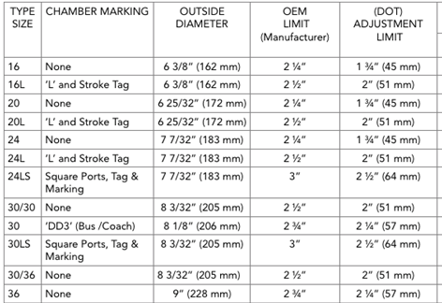
    - Verify brake shores are in adjustment if they are not then replace the ASA

- S-Cams & S-Cam Tubes
    - Inspect cam tubes for cracks, loose hardware or physical damage. If any is found, then a full tear down of that wheel end brake system is necessary.
    - Check cam bushing for wear by pressing up and pulling down on the ASA. Any excessive movement will require a full tear down and inspection of the brake components.
    - Properly lubricate the S-Cams and S-Cam tubes
- Air Lines/Tanks
    - Inspect air lines from front of the Tractor to the rear.
      - Verify the air lines are properly mounted, they are mounted away from pinch points, sharp edges and are secured to prevent damage to the air lines
      - Inspect air lines for chaffing, kinks, cuts, or dry rot. If any is found repair or replace the air line.
      - Verify the air lines do not have excessive splices, no more than 2 splices in an 18-inch section of airline. Listen for audible air leaks, if any air leaks are heard, perform a visual leak test using a soapy-water solution to pin point the leak and repair the leak.
    - Inspect Tractor air tanks
      - Visual inspect air tank for signs of damage, rust and verify proper mounting. Verify air tank is free of water and air tank drain has a pull cable to allow the driver to operate the drain without having to go under the tractor.
- Wheel End Components
  - Wheel Bearings -To be performed once a year
- Lift wheel end and spin wheel, listen and feel for any roughness in the rotation. If any is heard or felt a full teardown is required.
- Remove hubcap and perform a wheel bearing end play check. Using a magnetic dial indicator. The dial indicator should be attached to the hub or brake drum with its magnetic base. Adjust the dial indicator so that its plunger is against the end of the spindle with its line of action approximately parallel to the axis of the spindle. Grasp the wheel or hub assembly at the 3 o’clock and 9 o’clock positions. Push and pull the wheel-end assembly in and out while oscillating the wheel approximately 45 degrees. Stop oscillating the hub so that the dial indicator tip is in the same position as it was before oscillation began. Read the bearing end-play as the total indicator movement. *Acceptable end-play is .001"-.005". If the end-play is out of spec, adjust bearings.
  - Hub Caps

- Visually inspect the hub cap for broken bolts, broken window fasteners, missing expansion plug or plugged breather port. If any issues are found replace, as necessary.
- Clean the hub cap to remove any built-up dirt and road grime.
- Visual inspect hub cap window. If the fluid level cannot be easily seen with the naked eye replace the hub cab.
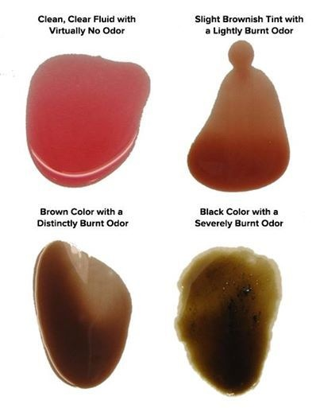
- Inspect hub cap for sign of a hub cap seal leak. If a leak is present remove and replace hub cap gasket. Fill hub with fresh fluid (or grease if equipped). Remove rubber plug and visually inspect fluid for discoloration, or signs of the fluid being burnt. Use a magnet to check the fluid for metal particles. If the fluid is burnt, discolored, or has metal particles, a full tear down and inspection of that wheel end is mandatory.
- Verify proper fluid level inside the hub, top off, as necessary. Use caution to not overfill. Overfilling will result in pre-mature wheel seal failure.
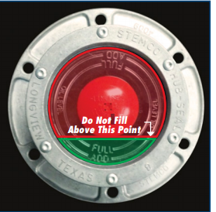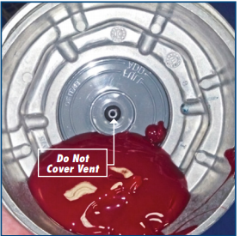
  - Wheel Seals
- Visually inspect the wheel seals for leaks.
- Class I Leaks. Class I leaks are identified by a wetness or discoloration not great enough to form drops. It is more of a seepage than a leak. Seepage can be a normal occurrence during large temperature swings because metal and rubber expand at different rates.
- Clean seal area well and release the unit after completing the PM
- Class II Leaks. Class II leaks are identified by a flow of fluid great enough to form drops but not great enough to cause the drops to fall from the leak point.
- Class 2 oil leaks require a full tear down and wheel seal replacement. During wheel seal replacement inspect wheel bearings, races and spindle for any signs of scoring, heat damage or pitting of the metal.
- Class III Leaks. Class III leaks are identified by a flow of fluid great enough to form drops that fall from the leak point.
- Class 3 oil leaks require a full tear down and wheel seal replacement. During wheel seal replacement inspect wheel bearings, races and spindle for any signs of scoring, heat damage or pitting of the metal.
  - Wheels
- Visually inspect wheels for cracks, bent rim, or rust.
- Check around lug nuts for signs of rust, which indicates a loose lug nut.
    - If no loose lug nuts are found, recheck torque on all lug nuts using a calibrated torque wrench. If loose lug nuts are found, the wheel stud associated with the loose lug nut and the two surrounding MUST be replaced.
- Wheels will be torqued to 450-500ft lbs using a calibrated torque wrench.
- ANY WHEEL THAT HAS BEEN REMOVED MUT BE RETORQUED WITHIN 100 MILES.
- When a wheel has been removed you must inspect the lug nut holes to verify, they are not worn, or damaged.

  - Tires
- Tires should be checked for improper wear patterns, legal tread depth, physical damage, and proper inflation.
- Visual inspect the tire for cuts, building, chunks of tire rubber missing, tread separation, and improper recap seams. If any of the following conditions exist refer to the Radial Tire Conditions Analysis Guide or remove the tire and have it verified by the tire vendor.
- Inspect for any foreign object penetration. Do not remove the object. Take the tire off the unit and have it inspected for re-use by the tire vendor.
- Tread depth needs to be checked in 3 points across the tire; outer, center, and inner tread groove. It must also be measured at the lowest point on the tire.
- Minimum tread depth is 4/32” at the lowest point on the tire, if a tire is at 4/32” it is out of service. Tires should be matched according to size, with no variation greater than 1/4” on the same wheel end or across the.
- When checking the tire pressure if the tire was lower than 15 psi above spec, the tire needs to be removed and sent for inspection.
- Running under-inflated tires for an extended period will increase the chances of a catastrophic blow out.

- Chassis inspection
    - Inspect frame for cracks, damage, or rust
- Any cracks, damage or excessive rust is OOS criteria Excessive rust is considered large chunks of material coming off, or any holes in the frame.
- Surface rust needs to be cleaned and painted.
    - Check for loose fasteners
      - Loose fasteners can be seen by rust streaks or rust around the bolts or nut.
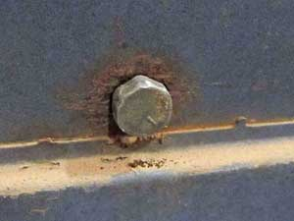
      - Replace all loose fasteners with new and torqued to factory specifications.
    - Check for unsecured air lines, wiring harnesses and components
      - Re-secure all air lines, harnesses or components as necessary.
    - Check air lines for excessive repairs
      - No more than 1 splice/connector in an 18” area

Suspension
    - Inspect shocks for signs of leaking, damage or loose fasteners
    - Signs of shock leaking are grounds for immediate replacement.
        - If it is just oil mist, clean shock and annotate to recheck on next PM. Misting is normal and not considered a leak.

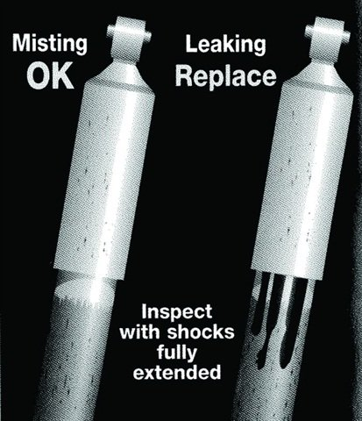

    - Air Suspension Components
        - Look for chafing, cracking or any signs of component damage. Look for misplaced air lines that may rub on air spring bellows.
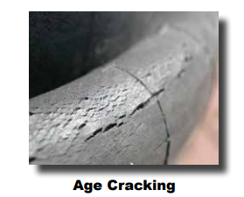

  - Ensure that the upper bead plate is tight against the underside of the frame and that the mountings show no sign of movement.
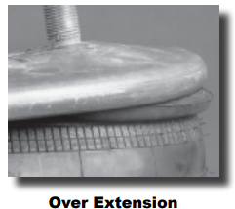
  - Air springs should be cleaned regularly, removing dirt and dust that may build up around the bead. Any grime in this area will eventually wear through the rubber bellows and cause premature failure to occur.

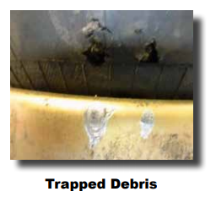

  - Inspect for leaks using a soap and water solution spray the air bags and fittings and look for signs of bubbling. 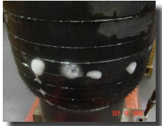
  - Inspect and torque U-bolts to manufacturer specifications
        - Refer to OEM manuals for proper torque spec
  - Inspect Pivot bushings for wear or deterioration
  - Inspect leveling valve for proper operation and proper install of height control rod.
  - CHECK FOR LOOSE FASTNERS AND RETORQUE ALL FASTENERS TO SPEC
    - Grease all chassis lubrication points
- LEAF SPRING SUSPENSION
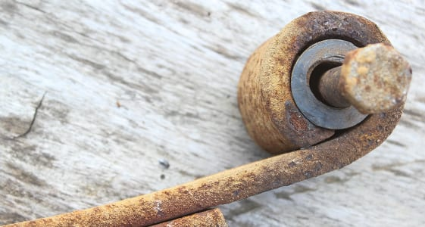
        - Check leaf spring eye bushings for signs of wear, damage, or deterioration.

        - Inspect Leaf Springs for cracked or broken leaves
        - Inspect and torque U-bolts to manufacturer specifications.
- Refer to OEM manuals for proper torque spec
- Inspect Equalizer bushings for wear or deterioration
            - Typical signs of a worn equalizer bushing are when the tractor is on a flat level surface and the equalizer is not level
- Inspect wear pads and replace, as necessary.
- Check for loose fasteners and replace all loose fasteners with new and torque to spec.
- Grease all chassis lubrication points.

Alternator, Battery, and Starter Check

          - Verify unit is charging properly, gauge should read approximately 14v
          - Check and clean battery cables at the battery
          - Load test batteries

Check fluid levels
          - Check engine oil level
          - Check coolant level
          - Check transmission fluid level
          - Check rear end fluid level
          - Check steer axle hub cab levels
          - Check Power Steering Fluid Level
          - Top off all as necessary

Check Steer Axle components
    - Check tie rods for excess play
    - Check steering Knuckle for excess play
    - Check drag link for excess play
    - Lubricate steer components as necessary

Emergency Equipment
          - Test city and air horn operation
          - Inspect all lights
          - Inspect Defrost and AC System for proper operation
          - Check fire extinguisher for certification date
          - Verify cab card, permits, registrations are current
          - Verify E-log Card is present

Drive line
- Inspect drive line u joints for proper play
ii. Inspect carrier bearing for proper play
  - Lubricate u joints

Engine
- Inspect belts and hoses for wear
ii. Check belts for proper tension
- Inspect fan hub for play and proper engagement
- Inspect for signs of exhaust leaks
- Inspect for loose clamps or damaged hoses on the charge air system
- Pressure test cooling system.

5th Wheel
- Inspect 5th wheel for physical damage on the deck plate, jaws, and hardware
- Inspect for loose hardware and replace hardware if necessary
- Using an approved 5th wheel testing tool verify there is no excess slack in the 5th wheel and adjust if necessary
              - Example of approved tool: SAF-Holland 5th wheel tool PN TWD TFTLN5001
              - Free play should be 0.040" (1.02 mm) minimum. If there is still excessive free play in the locks adjust 5th wheel tension. (use manufacturers adjustment procedures)
- Free front to rear rock on brackets with greaseless liners. If the fifth wheel does not rock freely, remove the top plate and inspect the bracket liners. Replace liners that are broken or have worn excessively. Check the bracket liner thickness at every scheduled maintenance. Replace liners if the thickness is less than .125" at the top of the liners.
- Lubricate 5th wheel top plate and jaws

Cab/Body
          - Visually inspect cab, hood, and bumper for damage, document any damage and take pictures.
- Any loose components must be properly secured
          - Inspect windshield for any cracks or chips in driver’s field of view
              - Chips bigger than ¾” are out of service criteria
          - Inspect seatbelts, and seats for damage and serviceability
- Tears or fraying in the seatbelt are out of service criteria and must be replaced
          - Inspect mirrors for proper function, if electronic they must move with the controls. Verify glass is clear with no cracks or hazing that cannot be cleaned
          - If straight truck, verify body is intact with no loose components or damage
          - Verify floor is in good condition with no damage to floorboards
          - Verify doors open and close properly, and locks work as designed
          - Lubricate doors

M2 Inspection-40,000 Mile Service
M2 Inspection includes the M1 plus the following inspection items.

Lube Oil and Filter Service
- Drain and change oil
- Replace oil filter
- Replace fuel filters
- Replace fuel water separator if equipped
- Change air filter
- Oil sample analysis will be sent off for engine health report

Cooling System
- Test cooling system using approved testing method.
        - If coolant does not meet manufacturer spec. drain and refill cooling system with correct coolant.

M3 Inspection-250,000 miles

Transmission Inspection
- Drain transmission fluid, inspect magnetic plug for excess metal
- Replace filter if equipped
- Clean drain plug and reinstall
- Refill transmission fluid with correct grade of synthetic oil (see manufacturers manual for correct grade)
- Recheck fluid level

Differential Inspection
- Drain Differentials, inspect drain plug for excess metal
- Install drain plug and refill differentials with correct grade of fluid. Let sit 10 minutes and recheck level. Top off if necessary (see manufacturers manual for correct grade)

Coolant
- Drain cooling system
- Refill cooling system with correct coolant (see manufacturer spec)
- Pressure Test Cooling System.

Desiccant Dryer Cartridge
- Drain air system
- Remove Dryer Cartridge
- Inspect Dryer Housing
- Replace Dryer Cartridge
- Run Engine and check for leaks at Dryer.

Aftertreatment PM Service-3 years or 350,000 miles

DPF Filter
- Remove and replace DPF Filter(s)
- DPF filters will be replaced with Filters remanufactured to OEM Spec ONLY.
- Bake and blow cleaned filters will not be used due to high failure rates.
- Update aftertreatment control module with new DPF Serial numbers and reset ash accumulator.
- Run Parked Regeneration to verify no leaks and system is operational
*Ash Accumulator may illuminate check engine light if Ash Accumulator is not reset at the time of filter replacement
**If ash accumulator comes on before 350,000 miles since last replacement, replace filters and reset ash accumulator.

DEF Filter replacement
- Remove DEF pump filter
- GHG14 models replace filters on def doser
- Runs system test to verify no leaks

Valve Lash Adjustment- 500,000 miles

Initial adjustment
i. Initial adjustment is at 100,000 miles after purchase of a new truck or engine.

Secondary adjustment
i. Second adjustment will be conducted at 500,000-mile intervals
ACKNOWLEDGEMENT OF RECEIPT OF MANUAL

This is to acknowledge that I have received a copy of the Tractor Preventative Maintenance Manual 2020 Rev 1. I understand that this manual is a guideline for proper preventative maintenance for Energy Transport Logistics. I also understand and agree that it is my responsibility to read and become familiar with the contents of this manual.

Date _______________________
Employee Signature _________________________________________________
Employee Name (Print) _______________________________________________
Company _______________________________________________

Return signed copy to Fleet Maintenance Manager

