


1. Make a call with a phone number or name
Calls in Microsoft Teams

If you have a calling plan enabled, you can call anyone from Teams.
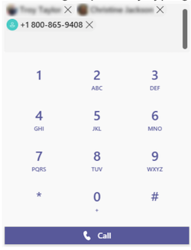
To dial a number from Teams, go to Calls and from the dial pad, enter the number of the person you want to reach. Then click Call .
To call using someone’s name, go to Calls and from the dial pad text box, type the name of your contact.
To make group calls, enter multiple names and/or numbers into the dial pad, and click Call .

Make or answer a call from anywhere
Select either Video call or Audio call . Any call can be a video call or an audio-only call. It's always up to you.

Answering a call is simple too. Just select Video call or Audio call when prompted. When someone calls you, you'll get a notification that lets you accept or decline the call.

2. Turn a chat into a call
The person you are chatting with (or the people, if it's a group chat) can also receive a call from you.
Calls in Microsoft Teams


With one click, you can make any chat into a call in Teams.
Go to the Chat tile.

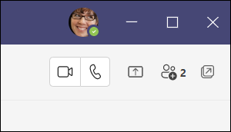
When you're in a chat, select Video call or Audio call in the upper-right corner of Teams.
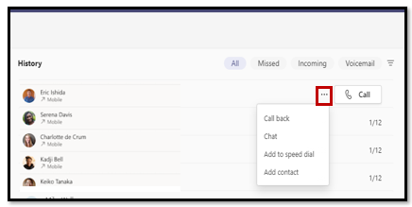
The person you are chatting with (or the people, if it's a group chat) will receive a call from you.
You can also chat with that contact, add them to speed dial, and add them to your contacts, all from the More actions menu.
3. See your call history and filter your calls in a new way
Your call history moves to the center of the calls experience and shows a list of past calls (including missed calls).
To return a missed call, hover over a contact from your call history list.
Calls in Microsoft Teams

Select More actions by expanding the 3 dots .
Select Call back .
Your call history moves to the center of the calls experience and shows a list of past calls (including missed calls).

Calls in Microsoft Teams

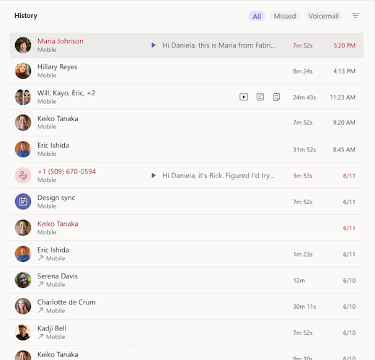
To review a list of calls you’ve missed, lists of calls that came in, and your voicemail, select between the available filters at the top of the call history list.

4. Access your speed dial, contacts, and voicemail summaries in one place
Contact groups organize your teammates to help you find or reach certain people based on a role or team.
Your speed dial contacts now appear to the right of Teams, along with any contact and call groups you manage.
Calls in Microsoft Teams

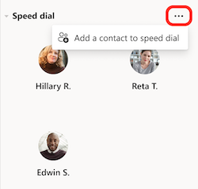
To add someone to a call group, select More actions, by hitting the 3 dots next to a contact group name.
Choose Add a contact.

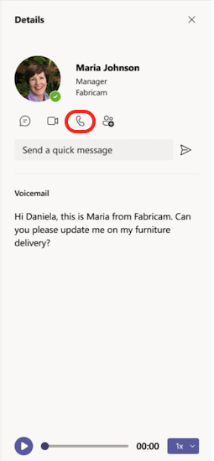
Calls in Microsoft Teams

Another familiar tool to get the most out of calls is voicemail. Review your voicemail summaries and transcripts from the right side of Teams, and call someone back from your voicemail by selecting More actions next to their name > Call back from the call history list, or by clicking Call under the contact details.

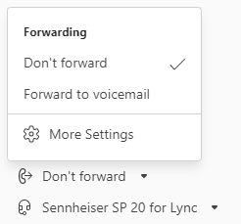
5. Manage important call settings in a new menu
Now you can manage your call settings directly within the calls experience.

To change your connected calling device, select from the dropdown menu at the bottom left of the calls experience. You can also manage call forwarding and call groups from this quick settings menu.

