ENTERING A MANUAL FLAT RATE (CHARGE) PRO

Enter PRO as regular shipment
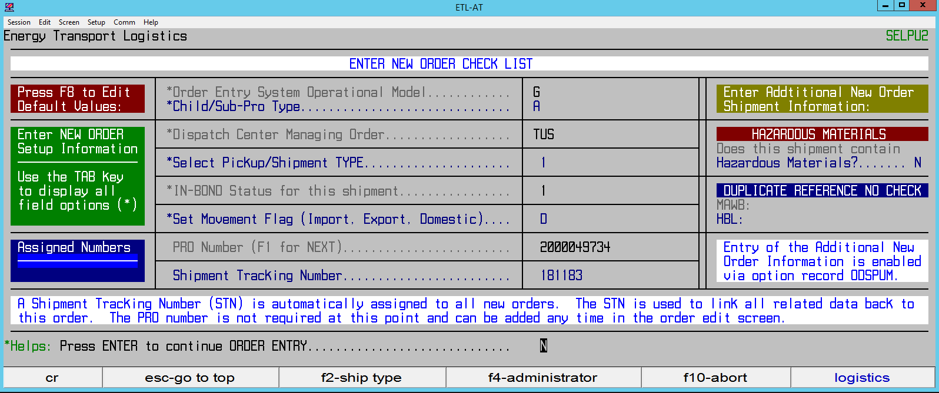

In the RATE field please note 2 in Mode; leave T in Method and if no FSC enter N in APP FSC
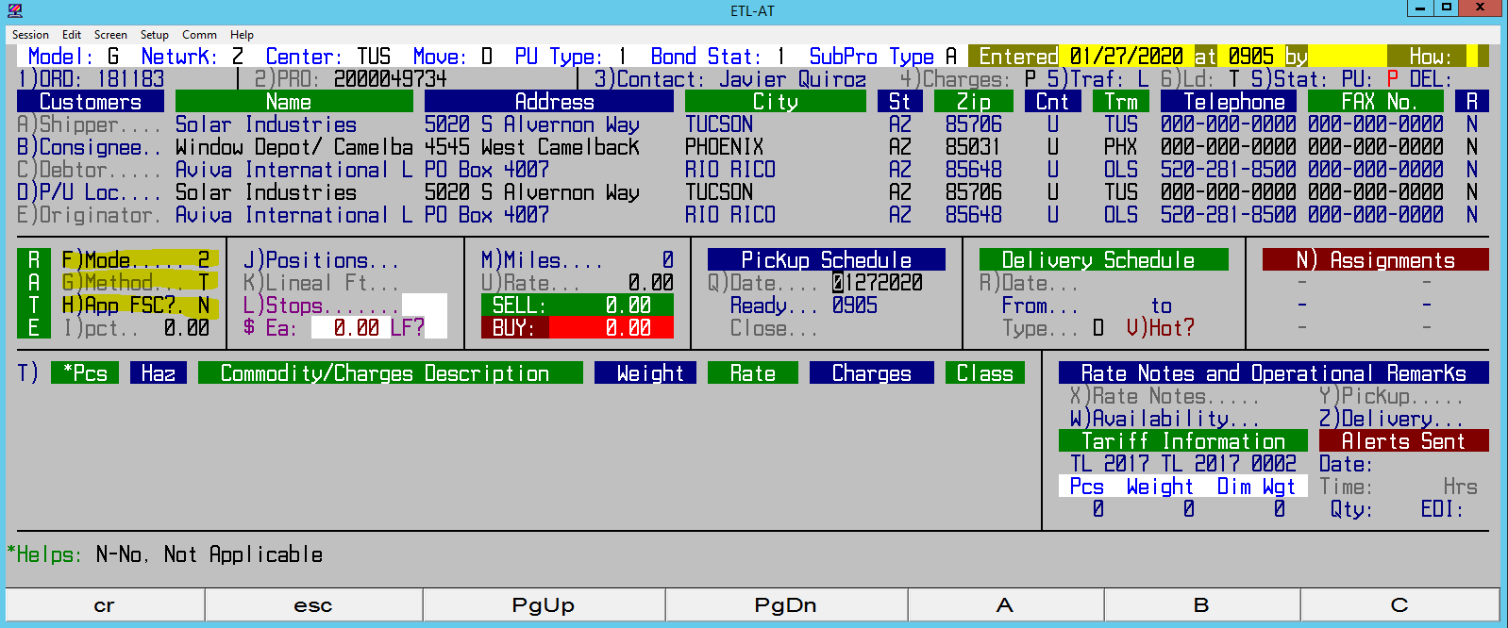

In Commodity/Charges field please make sure to enter FAK then FR (FLAT RATE) and enter charges
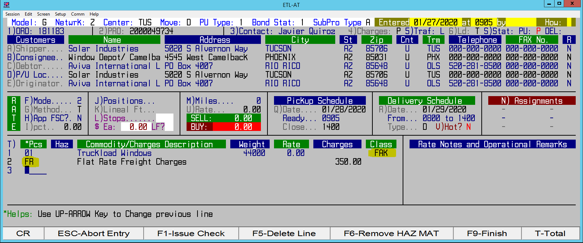
Enter F4 reference numbers and F9 to complete file.

